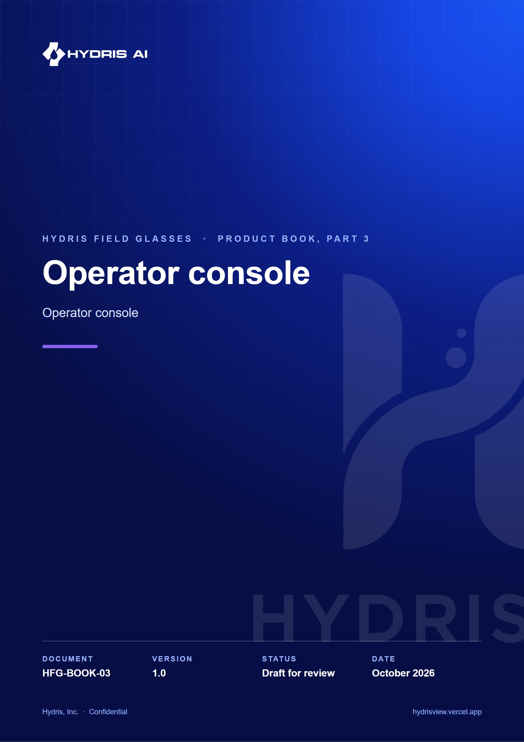
Document control
Document | Operator console (HFG-BOOK-03)
Version | 1.0
Status | Draft for review
Owner | Product and engineering, Hydris
Audience | Leadership, product, engineering, design, partners and pilot customers
Product | Hydris Field Glasses: website, operator console, glasses app, Android app, API
Source of truth | docs/product/_part03.md in tarun-km/hydrisview (this Word file is generated from it)
Classification | Confidential: Hydris, Inc. and named partners
Revision history
Version | Date | Author | Changes
1.0 | October 2026 | Product and engineering, Hydris | First edition

Contents
1 Operator console 4
1.1 Purpose, users and information architecture 4
1.2 Overview dashboard 6
1.3 Plant model: sites, assets, sensors and the plant map 7
1.4 Telemetry and sensor monitoring 8
1.5 Alarms 9
1.6 Inspections and maintenance 11
1.7 Documents and SOPs 12
1.8 Field glasses fleet 13
1.9 Audit documents: review and approval 15
1.10 Reports, insights and the assistant 16
1.11 Organization admin 16
1.12 Console success metrics and gaps 17

1 Operator console
The operator console is the web application at /console where supervisors, managers, auditors and administrators run the plant record. Field operators produce data with the glasses and the Android app; the console is where that data is dispatched, triaged, reviewed, approved and reported. It is one Next.js surface (apps/web/src/console) over the same API that serves every other client, so a value acknowledged on the glasses is the same record a manager sees on the overview a second later.
16  Navigation destinations  `Shell.tsx` |  | 6  Roles  38 permissions, `roles.ts` |  | 5  Alarm lifecycle states  resolve needs a note |  | 2 s  Realtime alarm target  NFR-002, not yet measured

1.1 Purpose, users and information architecture

Purpose and problem
Water and wastewater plants still run on paper log sheets, phone calls and spreadsheets. The supervisor cannot see which rounds are late, the manager cannot prove to a regulator who saw an alarm and when, and the auditor receives evidence that cannot be traced to a person. The console replaces that patchwork with one tenant-isolated, site-scoped workspace where every state change is attributed, timestamped and written to an append-only audit trail.

Users and jobs
Table 1. Console users and their main jobs
User | Role in code | Main jobs in the console
Shift supervisor | supervisor | Triage and assign alarms, dispatch rounds, review inspections, verify scanned documents, pair glasses
Plant manager | factory_manager | KPIs and reports, alarm rules, plant model, approve audit documents, devices and people
Compliance auditor | viewer plus report.read | Read the trail, approved documents and reports; export evidence
Organization admin | org_admin | Members, invitations, sites, glasses UI profiles, organization settings
Platform admin | users.is_platform_admin | Create and suspend customer organizations at /console/platform

Field operators and maintenance engineers can sign in to the console too, but their primary surfaces are the glasses and the Android app.

Information architecture
The navigation in apps/web/src/console/Shell.tsx groups destinations by intent. Each item declares the permission it needs; items the current role lacks are hidden rather than greyed out, and the API enforces the same check.
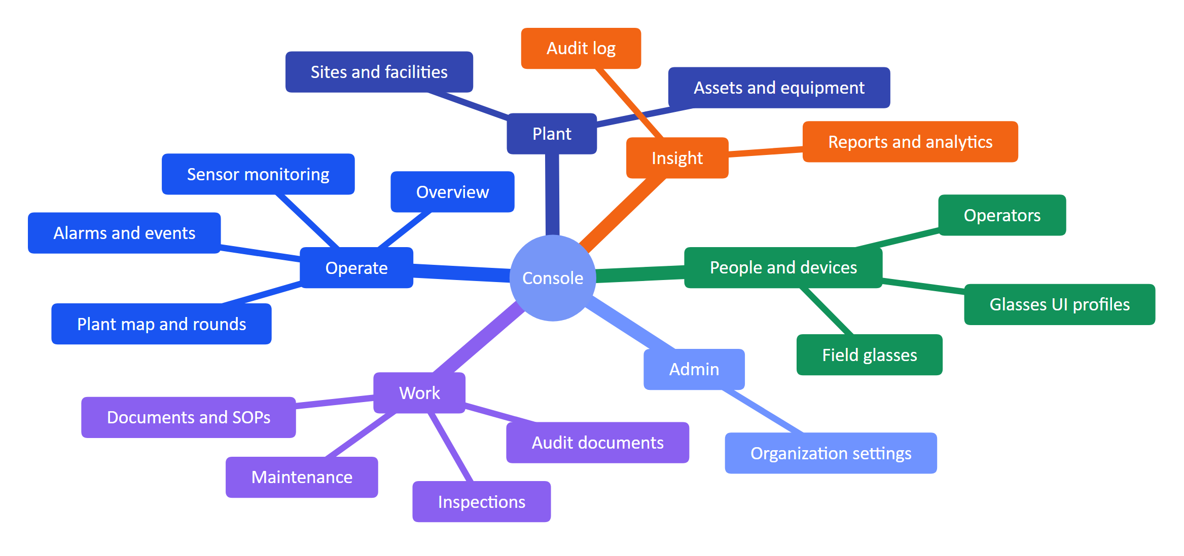
Figure 1. Console navigation groups and destinations (Shell.tsx)
A command palette (CommandPalette.tsx) gives keyboard access to every destination and to global search across assets, sensors, documents and work (FR-088). The console supports system, light and dark themes.

Role access summary
Permissions come from one fixed matrix (packages/domain/src/roles.ts, FR-012): can(role, permission) is the only check, and every role except org_admin is additionally scoped to its sites (FR-007). Row-level security in Postgres keeps tenants apart (FR-008).
Table 2. What each role can do in the console (summary of roles.ts)
Capability | Admin | Manager | Supervisor | Engineer | Operator | Viewer
Read plant, telemetry, alarms, work | Yes | Yes | Yes | Yes | Yes | Yes
Manage sites, assets, sensors, gateways | Yes | Yes | No | No | No | No
Manage alarm rules | Yes | Yes | No | No | No | No
Acknowledge alarms | Yes | Yes | Yes | Yes | Yes | No
Resolve alarms / close alarms | Yes / Yes | Yes / Yes | Yes / Yes | Yes / No | No / No | No / No
Manage and review inspections | Yes | Yes | Yes | No | No | No
Manage maintenance | Yes | Yes | Yes | No | No | No
Pair glasses / manage devices and profiles | Yes / Yes | Yes / Yes | Yes / No | Yes / No | Yes / No | No / No
Manage documents and SOPs | Yes | Yes | No | No | No | No
Verify / approve audit documents | Yes / Yes | Yes / Yes | Yes / No | No / No | No / No | No / No
Reports, audit log | Yes | Yes | Reports | No | No | Reports
Members and invitations / org settings | Yes / Yes | Yes / No | Read / No | No | No | No

NOTE
The auditor persona maps to viewer, which today holds read access plus report.read but not audit.read. Giving auditors the audit log page needs either a role change or a dedicated auditor role; this is an open product decision.

1.2 Overview dashboard

Purpose and scope
The overview is the first screen after sign-in. It answers "is anything wrong right now, and where?" in one glance: KPI tiles, open alarms by severity, asset health, live measurements with freshness, and recent activity. It is served by GET /overview (FR-089), the same endpoint that feeds the Android home screen (FR-092), so the console and the phone never disagree.
In scope: KPIs, open alarms, health roll-up, live values with freshness and synthetic labels, recent activity, realtime refresh. Out of scope: user-configurable widgets and cross-site benchmarking.
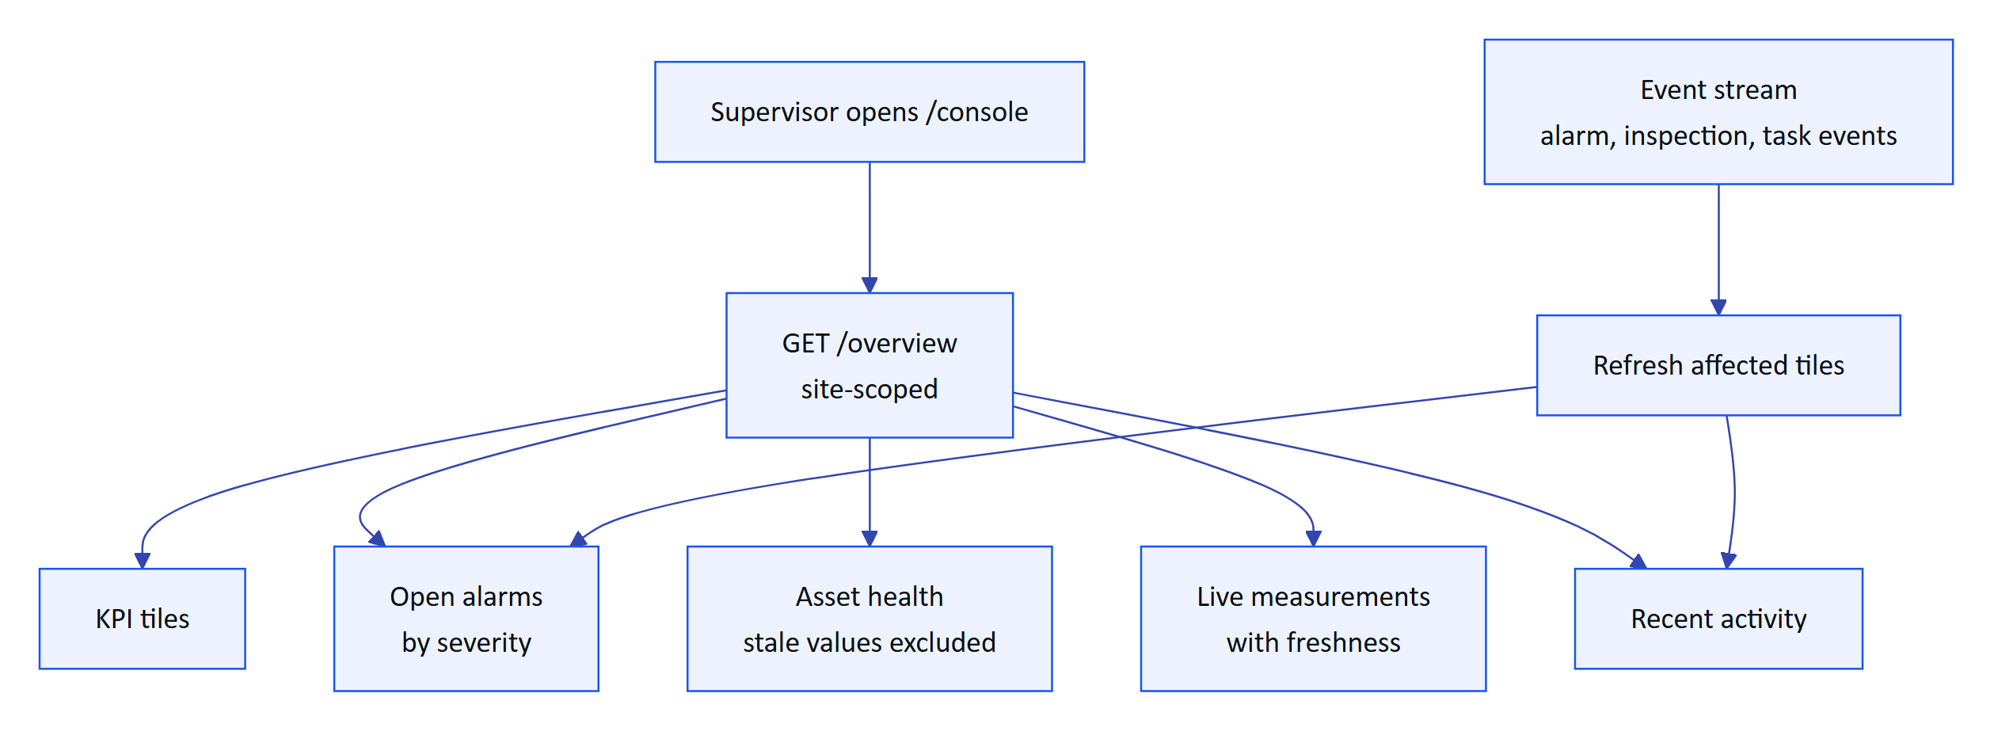
Figure 2. How the overview is assembled and kept current
Freshness is computed per sensor from its expected interval, and stale values are excluded from health roll-ups (packages/domain/src/freshness.ts). Synthetic demo values carry a visible label wherever they appear (FR-029).
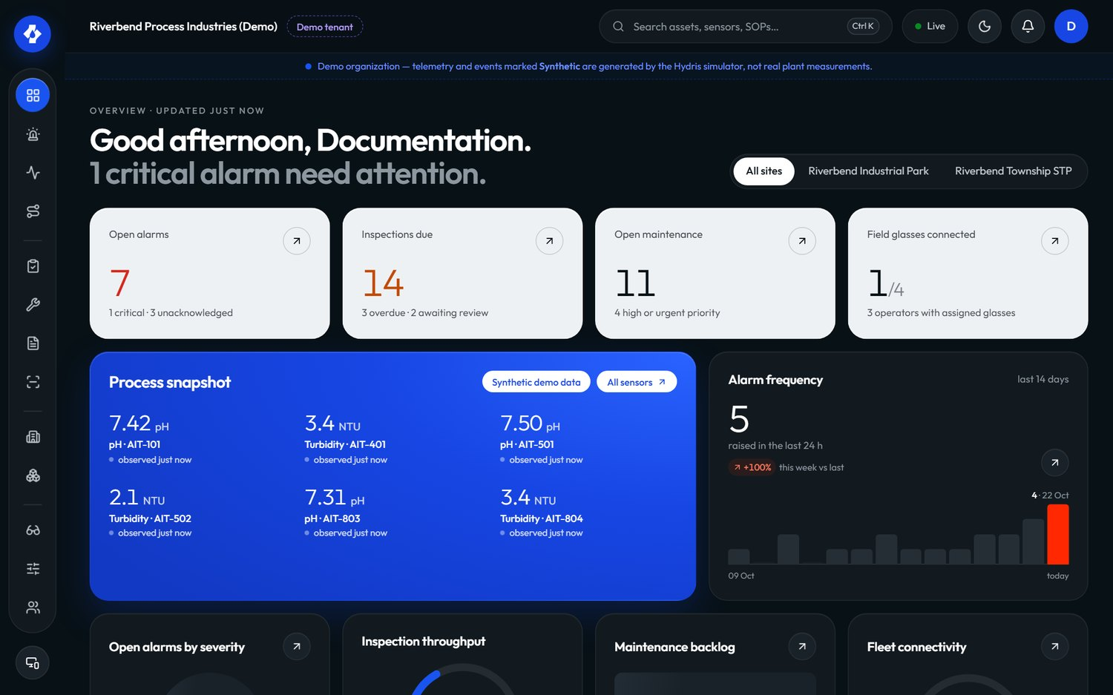
Figure 3. Overview dashboard in the console
Table 3. Overview requirements
ID | Requirement | Pri | Status
FR-089 | Overview with KPIs, open alarms, health and live measurements | M | Built
FR-026 | Freshness states shown; missing data never shown as a value | M | Built
FR-085 | In-app notifications in realtime, mark as read | M | Built
FR-088 | Global search across assets, sensors, documents and work | S | Built

Status: Built. Next step: per-user default site and a compliance tile once FR-120 lands.

1.3 Plant model: sites, assets, sensors and the plant map

Purpose and scope
Everything in Hydris hangs off the plant model: alarms, rounds, documents and devices are all scoped to a site and usually an asset. The plant model lets managers describe their plant once (site, facility, process area, asset, sensor) and place it on a map, so that operators walking the plant see the right asset and the right values.
In scope: hierarchy with map positions, archive and restore (FR-020), sensors for 16 measurands with unit normalization (FR-021), gateways with hgw_ API keys, the plant map with rounds overlay. Out of scope: digital twins, P&ID import, write paths to equipment (Hydris is read-only towards the plant).
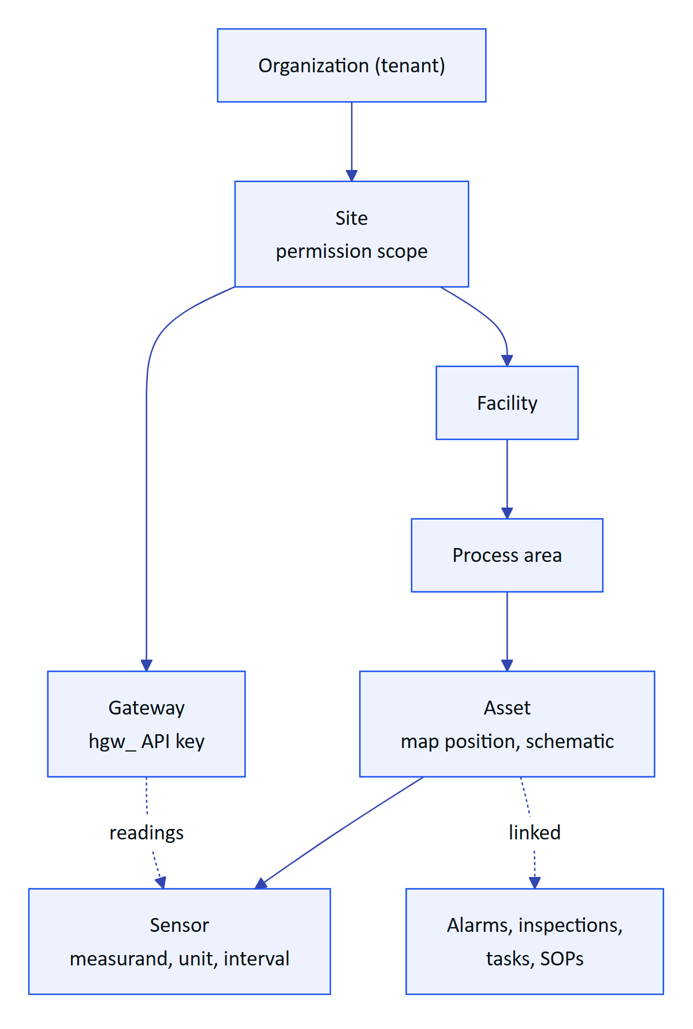
Figure 4. Plant hierarchy and what attaches at each level
The site level is the permission boundary: a site-scoped supervisor sees nothing from other sites. Archiving an asset removes it from glasses screens and assistant answers while keeping its history.

Plant map and rounds
The plant map (/console/map, apps/web/src/console/plant/map) places assets on the site layout and overlays route stops, so a supervisor can see where a round goes and where open alarms sit. The hierarchy navigator and asset schematic (HierarchyNavigator.tsx, AssetSchematic.tsx) give the same model as a tree and as a per-asset view of its sensors.
Table 4. Plant model requirements
ID | Requirement | Pri | Status
FR-020 | Site, facility, area and asset hierarchy with map positions, archive and restore | M | Built
FR-021 | Sensors for 16 measurands with unit normalization | M | Built
FR-007 | Site-scoped permissions | M | Built
FR-088 | Search by asset tag finds the asset and its open work | S | Built

Status: Built. Gaps: no bulk import of the asset register; map layout is drawn per site rather than imported from drawings.

1.4 Telemetry and sensor monitoring

Purpose and scope
Sensor monitoring shows what the plant measures, how fresh each value is, and where a value came from. The core promise is honesty: a missing reading is shown as "No data", never as zero, and every value carries its source (gateway, manual, lab or synthetic) and its time.
In scope: HTTPS gateway ingestion (FR-022), manual and lab entry with provenance (FR-023), append-only corrections (FR-024), history and CSV export (FR-025), freshness states (FR-026). Out of scope today: MQTT and OPC UA adapters (FR-027) and read-only historian connectors (FR-028), both Planned.

Ingestion flow
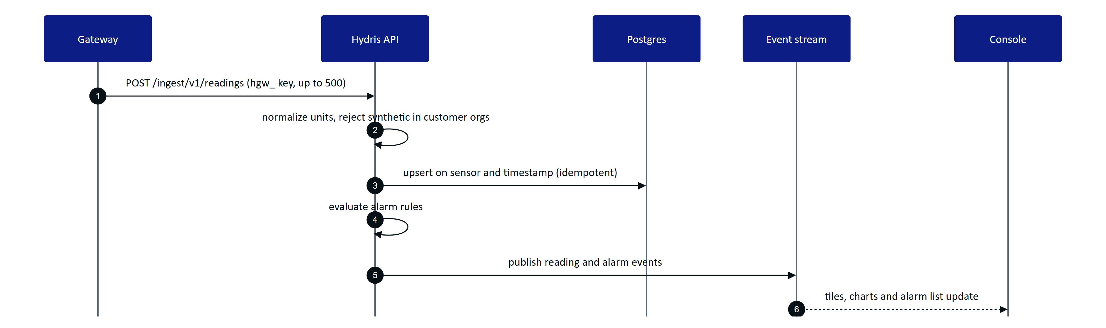
Figure 5. From a gateway reading to the console (telemetry.ts, alarms.ts, realtime.ts)
Replaying the same batch never creates duplicates because readings are keyed on sensor and timestamp. Synthetic readings sent into a customer organization are refused (FR-029).

Freshness
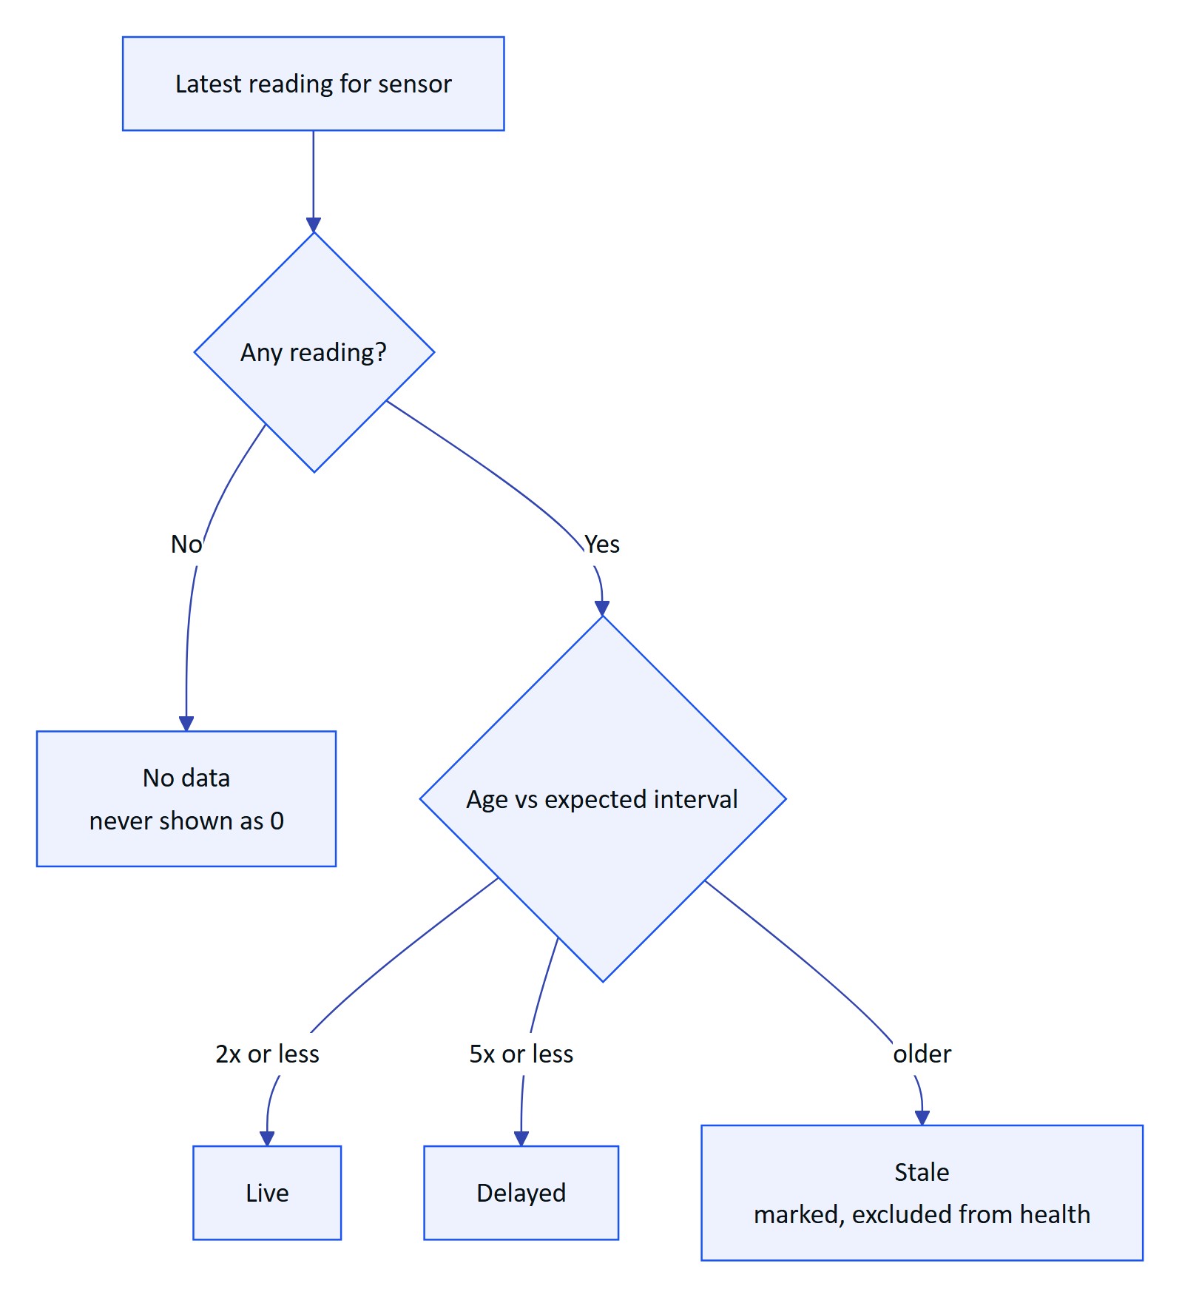
Figure 6. Freshness state of a sensor value (freshness.ts)

Corrections and history
A supervisor who finds a wrong value does not edit it. They add a correction or invalidate the reading; the original stays visible next to the correction with its author and reason (FR-024). Manual and lab entries (ManualEntryDialog.tsx) carry their provenance everywhere they appear. The sensor detail shows raw readings and history, and exports CSV with formula injection escaped (FR-025).
Table 5. Telemetry requirements
ID | Requirement | Pri | Status
FR-022 | Gateway ingestion, 500 per call, idempotent | M | Built
FR-023 | Manual and lab entry with provenance | M | Built
FR-024 | Append-only corrections (correct or invalidate) | M | Built
FR-025 | History, raw readings, CSV export | S | Built
FR-026 | Freshness live, delayed, stale, no data | M | Built
FR-029 | Synthetic data labelled, refused for customers | M | Built
FR-027 | MQTT and OPC UA adapters | S | Planned
FR-028 | Read-only SCADA and historian connectors | C | Planned

Status: Built for HTTPS. Next: MQTT and OPC UA adapters so pilots can connect existing gateways without custom code.

1.5 Alarms

Purpose and scope
Alarms turn readings into attributed work. The console is where alarm rules are defined, where supervisors triage and assign, and where the evidence of who saw what and when is kept. Acknowledging records that a person has seen the alarm; it never changes the process.
In scope: threshold and stale rules with deadband and on-delay (FR-030), the five-state lifecycle (FR-031), assignment, notes, history and linked SOP (FR-032, FR-112), realtime push (FR-033). Planned: escalation (FR-037), shelving (FR-038), push notifications when the app is closed (FR-034).

Rule evaluation
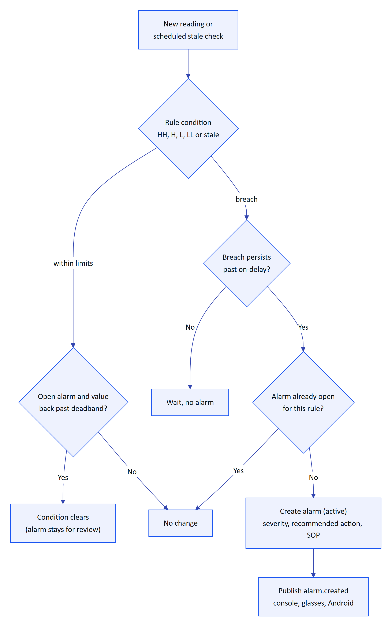
Figure 7. How a rule turns readings into an alarm (alarms.ts)
The deadband stops a value oscillating around a limit from raising and clearing repeatedly, and the on-delay ignores short spikes. Stale rules run on a schedule: every 30 s on a long-running server, but only once a day on the current Vercel cron (FR-035, Partial).

Lifecycle and permissions
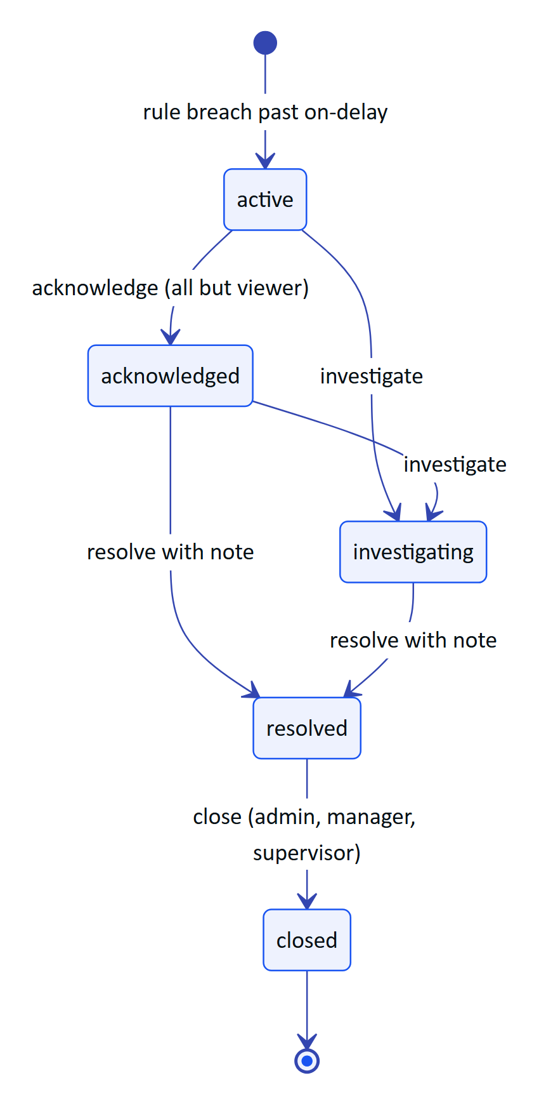
Figure 8. Alarm lifecycle with the permission each step needs (packages/domain/src/alarms.ts)
There is no path from active straight to resolved: someone must first see the alarm. Resolving requires a note, and the API rejects a resolve without one. Investigate and resolve are held by admins, managers, supervisors and maintenance engineers. Every transition writes a history row and an audit event.
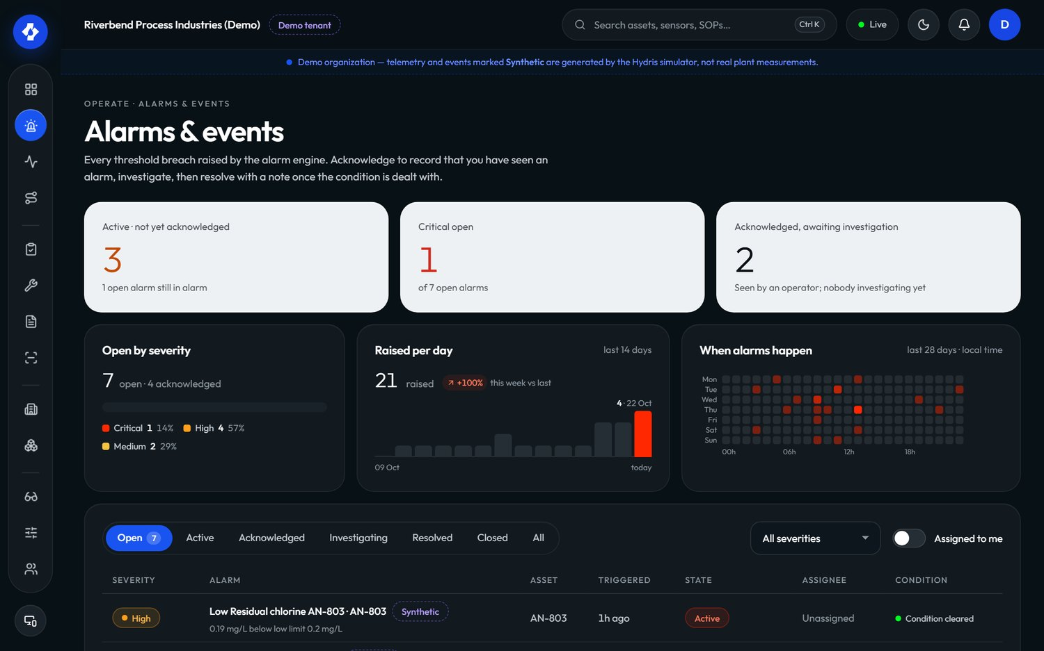
Figure 9. Alarms and events in the console

Escalation
Escalation is Planned for the pilot (FR-037): an unacknowledged critical alarm will notify the site supervisor after a configurable number of minutes, and the escalation will appear in the alarm history. Until then, supervisors rely on the realtime alarm list, the Android notification for critical and high alarms while the app runs (FR-097), and the median time to acknowledge in the alarm report.
Table 6. Alarm requirements
ID | Requirement | Pri | Status
FR-030 | Threshold rules with deadband and on-delay | M | Built
FR-031 | Five-state lifecycle, no resolve from active, note required | M | Built
FR-032 | Assignment, notes, history, recommended action, SOP | M | Built
FR-033 | Realtime push to console, glasses, Android | M | Built
FR-112 | Rule links a procedure shown with the alarm | M | Built
FR-035 | Stale-data alarms on a schedule | M | Partial
FR-037 | Escalation when unacknowledged | S | Planned
FR-038 | Shelving with reason and expiry | C | Planned
FR-034 | Push notifications when the app is closed | S | Planned

Status: core lifecycle Built. Gaps: stale evaluation cadence on serverless, escalation and shelving. Next: escalation first, because time to acknowledge is the headline alarm metric.

1.6 Inspections and maintenance

Purpose and scope
Rounds and maintenance are the daily work of the plant. The console lets a supervisor design what must be checked, send it to the right operator, and review the result; and lets anyone turn an alarm or an abnormal reading into a tracked task. Execution happens on the glasses (FR-041) and, for checklists, on the phone (FR-046).
In scope: versioned templates with five step kinds and routes with dispatch (FR-040), review with approve or return (FR-042), maintenance tasks with checklists and follow-ups (FR-043). Planned: recurring schedules (FR-047) and inspection execution on Android (FR-044).

Templates, routes and dispatch
A template is built in the console (TemplateBuilder.tsx) from steps: check, reading with expected range, choice with abnormal options, text and photo. Editing creates a new version, so inspections already dispatched keep the version they started with. Routes order templates along a walk and are dispatched to an operator. On the glasses, a reading outside its range, a failed check or an abnormal choice marks the step abnormal automatically.
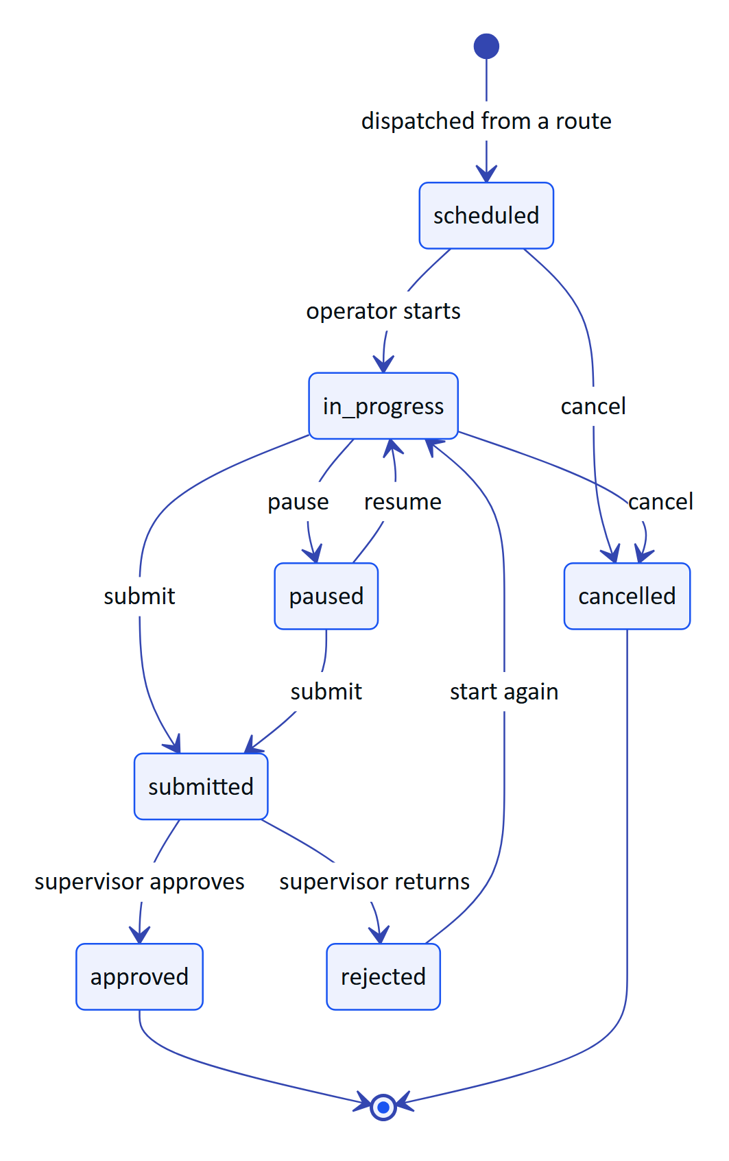
Figure 10. Inspection lifecycle as the supervisor sees it (workflows.ts)
Review is the console's job. The supervisor opens a submitted inspection, sees each step with abnormal ones highlighted and any photos, and either approves it or returns it with a reason. A returned inspection can be restarted and resubmitted, and history shows both submissions. Offline responses from the glasses are replayed idempotently, so the reviewer never sees duplicates.

Maintenance
Maintenance tasks are corrective, preventive, inspection follow-ups or alarm follow-ups, with a priority from low to urgent, a checklist and an activity log. A follow-up created from an alarm or inspection links back to its source.
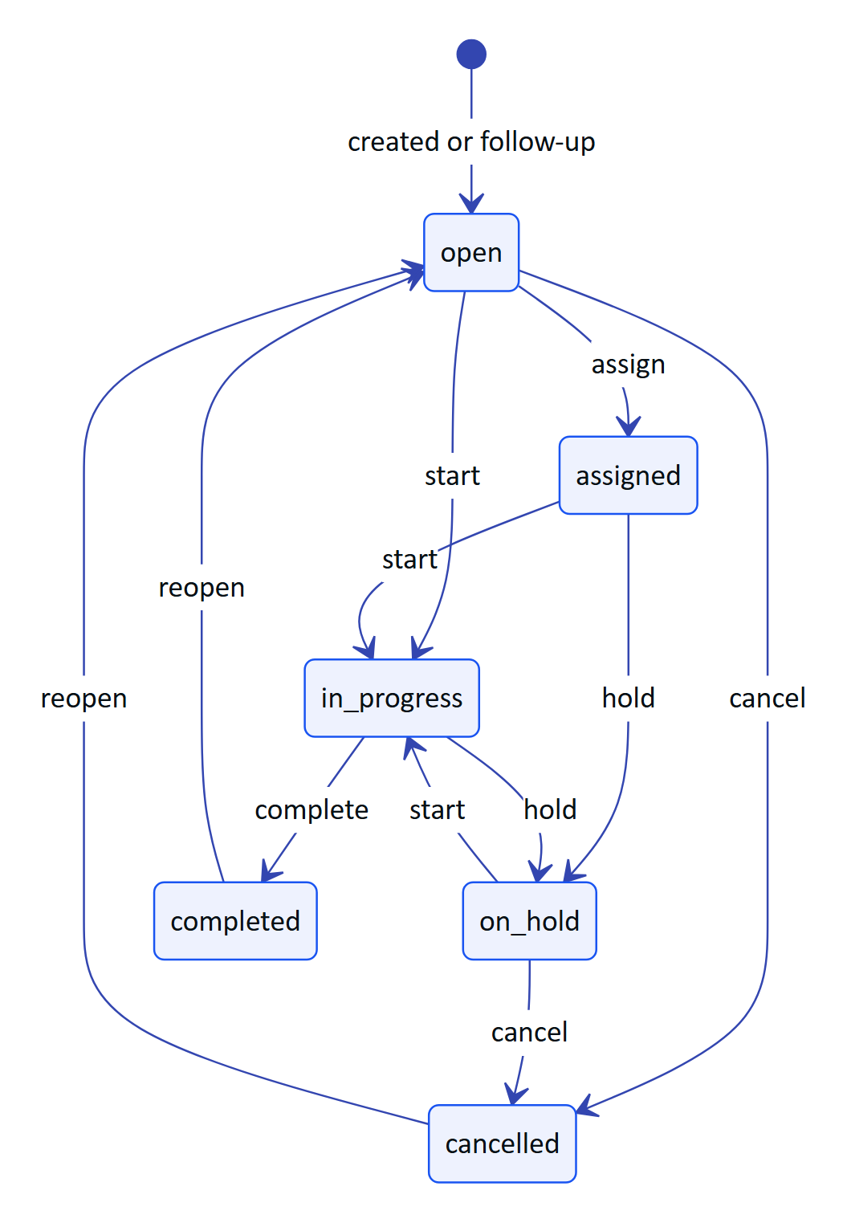
Figure 11. Maintenance task lifecycle (MAINTENANCE_TRANSITIONS in workflows.ts)
Table 7. Inspection and maintenance requirements
ID | Requirement | Pri | Status
FR-040 | Versioned templates, five step kinds, routes, dispatch | M | Built
FR-041 | Glasses execution with offline queue | M | Built
FR-042 | Submit, review, approve or return | M | Built
FR-043 | Maintenance tasks, checklists, follow-ups | M | Built
FR-046 | Tick checklist items from Android | M | Built
FR-045 | Photo steps from glasses or phone camera | S | Partial
FR-044 | Inspection execution in the Android app | S | Planned
FR-047 | Recurring schedules (calendar or runtime) | S | Planned

Status: Built for manual dispatch and review. Gap: every round is dispatched by hand. Next: recurring schedules, which also make on-time completion meaningful as a KPI.

1.7 Documents and SOPs

Purpose and scope
Operators need the right procedure at the asset, and only an approved one. The document library (/console/documents) holds SOPs, manuals, datasheets, safety notices and troubleshooting guides, each with versions and a scope of site, asset or asset type (FR-110). Only approved documents reach the glasses, the assistant and grounded retrieval (FR-111).
Lifecycle: draft, approved, archived. Managers and admins hold document.manage; everyone else reads. Alarm rules link a procedure that is shown with the alarm (FR-112). The library page also exposes grounded SOP retrieval (/assist): a question returns passages from approved documents with a safety notice (FR-070), so a supervisor can check what an operator will be told before it happens.
Table 8. Documents requirements
ID | Requirement | Pri | Status
FR-110 | Library with draft, approved, archived; versions; scope | M | Built
FR-111 | Only approved documents reach glasses and assistant | M | Built
FR-112 | Alarm rules link a procedure | M | Built
FR-070 | Grounded SOP retrieval with safety notice | M | Built
FR-113 | SOPs cached on glasses for offline reading | S | Built
FR-114 | Upload PDF manuals with text extraction | C | Planned

Status: Built for authored documents. Gap: existing PDF manuals cannot yet be uploaded and searched (FR-114).

1.8 Field glasses fleet

Purpose and scope
Glasses are shared, often unattended devices. The console makes them a managed fleet: pair a new pair to a site and an operator, see which are connected, suspend or revoke one that is lost, and control what each pair shows through UI profiles. The glasses never hold a user password; they hold a device credential that the console can end.
In scope: pairing approval (FR-050), device tokens and revocation (FR-051, FR-052), the device permission ceiling (FR-053), UI profiles (FR-054). The camera, capture button and Android registration are covered in the glasses part of this book.

Pairing from the console
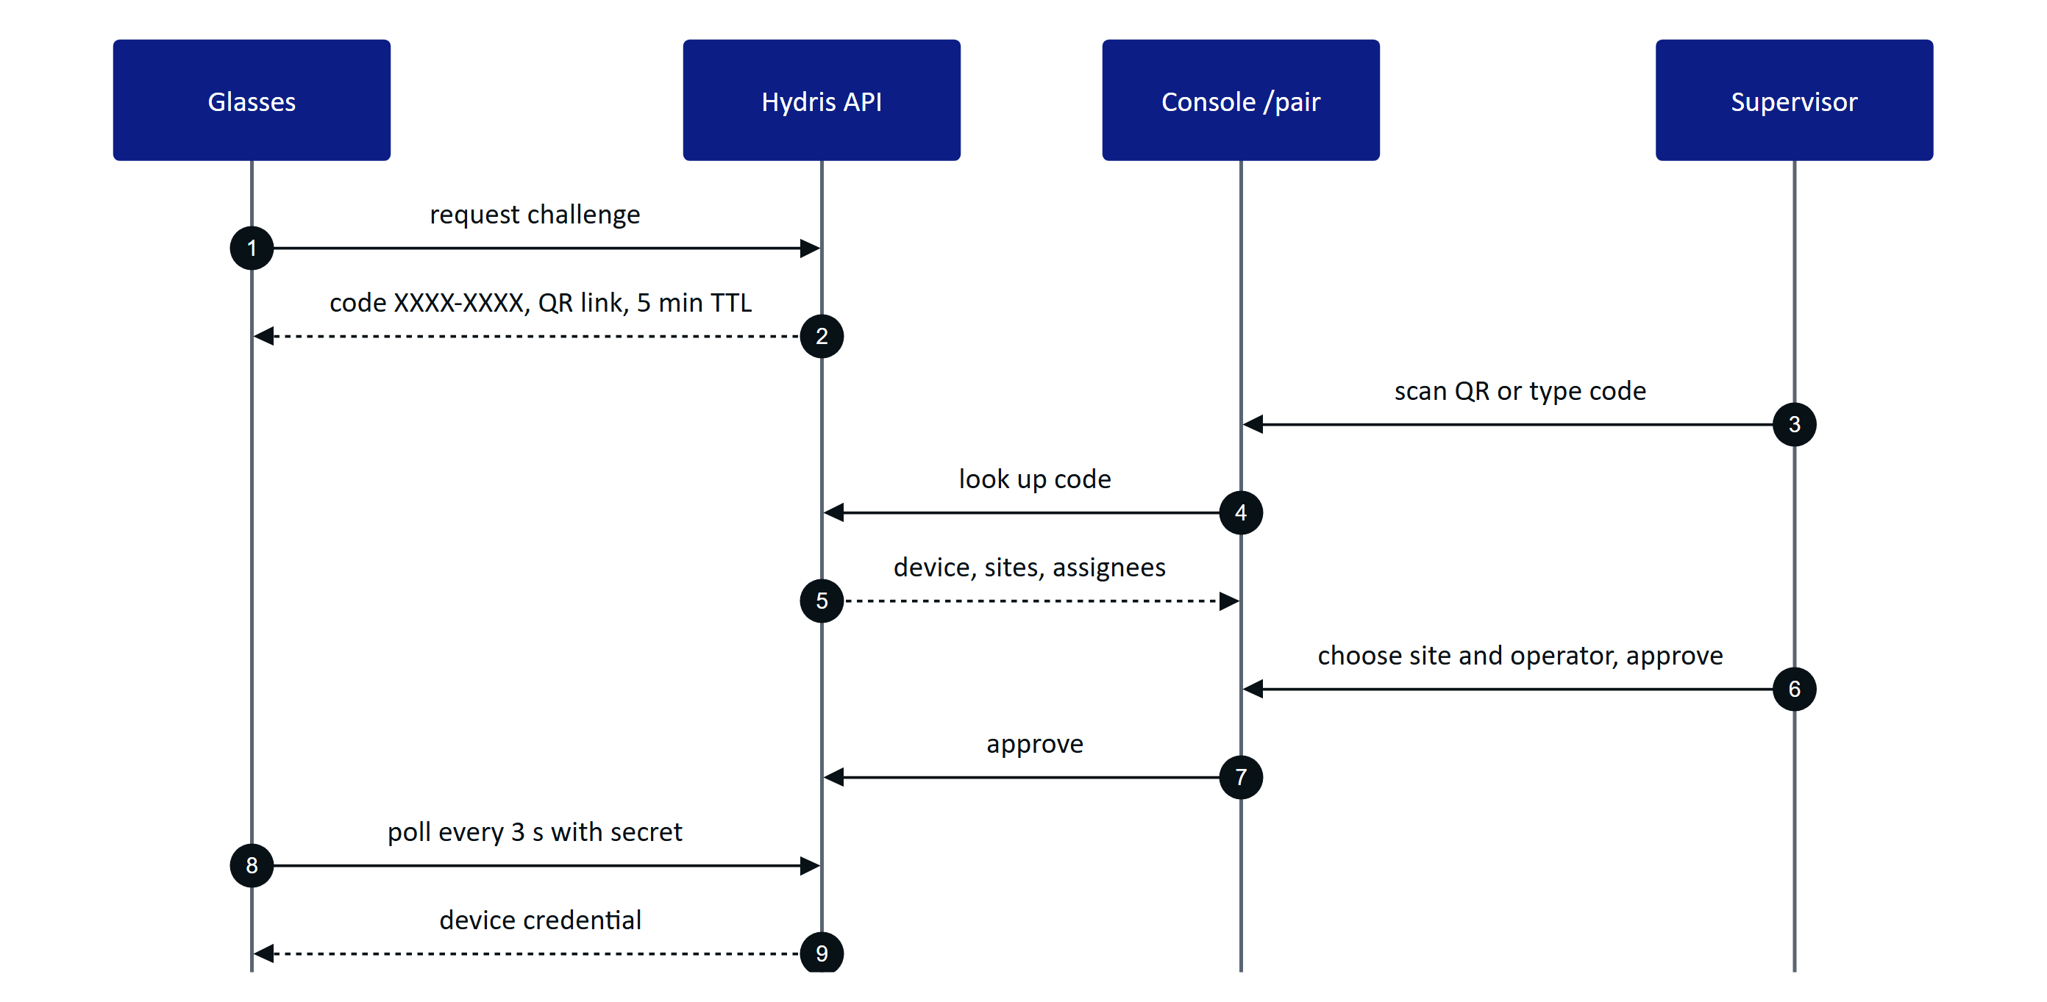
Figure 12. Approving a pairing from the console (devices.ts)
The code avoids confusable characters (no 0, O, 1, I, L, U), wrong-code lookups are rate limited, and the QR link never carries a credential. The approver needs device.pair, which every role except viewer holds.

Device states
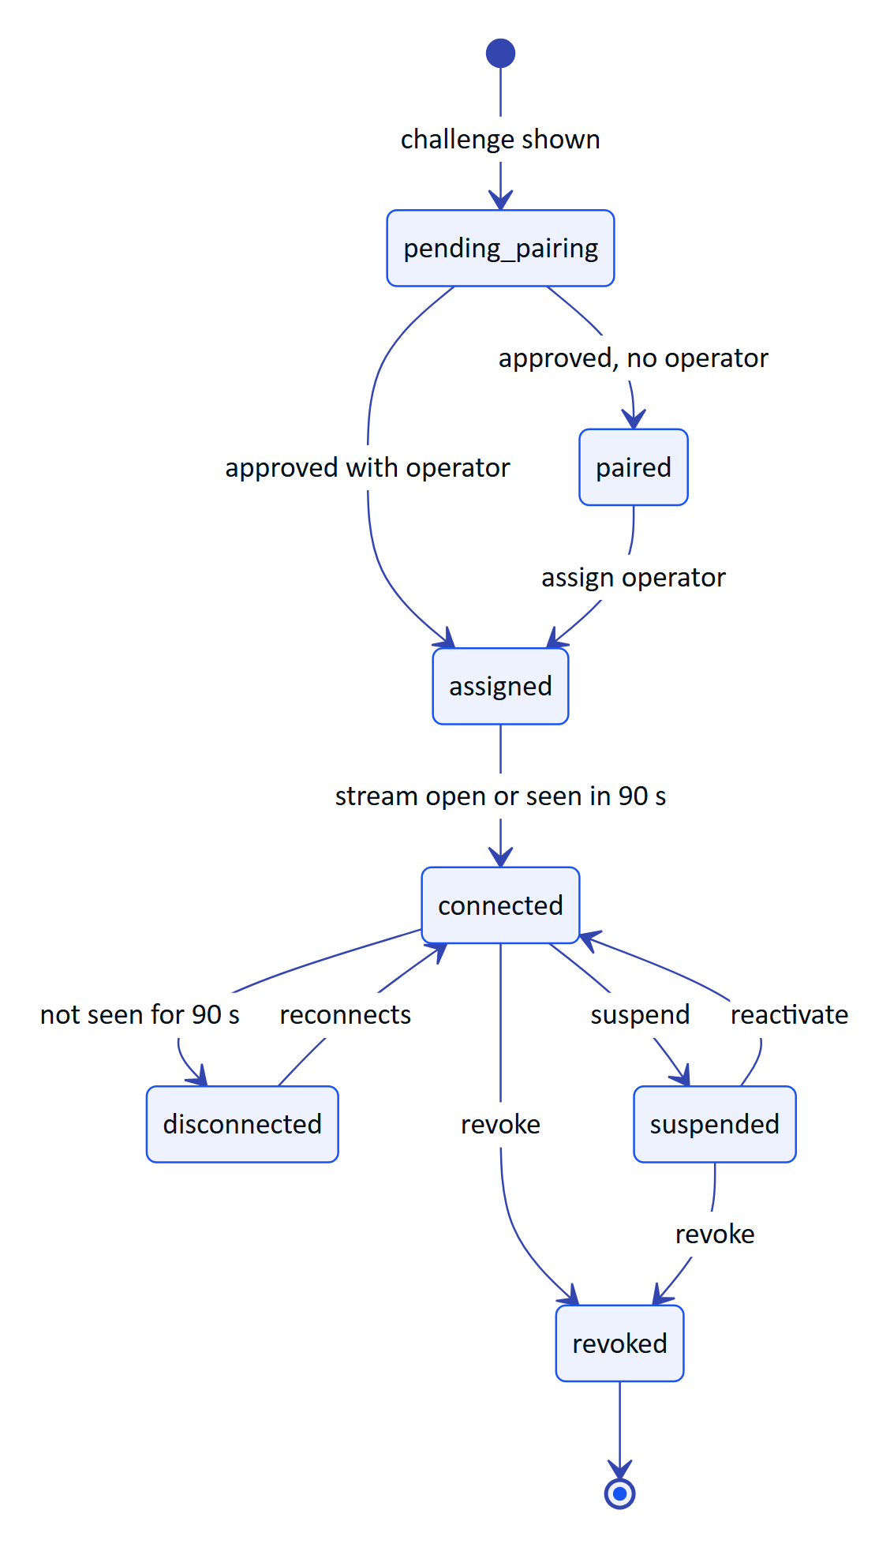
Figure 13. Device states shown in the fleet list (deriveDeviceState in devices.ts)
Revocation takes effect on the next request and closes an open event stream within 30 s (FR-052). Device access tokens last 15 minutes and refresh tokens rotate with reuse detection. Whatever role the assigned operator has, a device can never exceed the device permission ceiling: glasses paired to an admin still cannot manage members (FR-053).
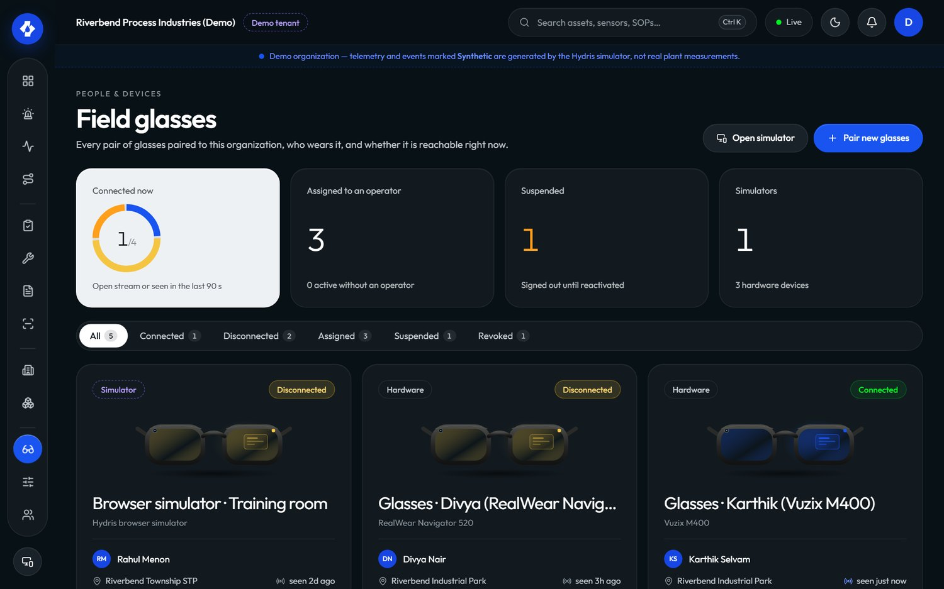
Figure 14. Field glasses fleet in the console

UI profiles
A UI profile controls what the glasses show (/console/glasses-profiles, ui-profiles.ts). Profiles are edited as drafts, published, and can be rolled back. Assignment can be made to a device, a user, a role or the whole organization; the most specific assignment with a published version wins. Publishing pushes the change live, so the glasses screens change without a restart. Managing profiles needs device.manage (admins and managers).
Table 9. Fleet requirements
ID | Requirement | Pri | Status
FR-050 | Pairing code, QR, 5 min TTL, 3 s polling, approval | M | Built
FR-051 | Device tokens, rotation, reuse detection | M | Built
FR-052 | Suspend, reactivate, revoke, reassign | M | Built
FR-053 | Device permission ceiling | M | Built
FR-054 | UI profiles: draft, publish, rollback, precedence, live push | S | Built
FR-058 | Log out and unpair from the glasses menu | M | Built

Status: Built. Next: fleet health signals (battery, app version) once the glasses bridge reports them.

1.9 Audit documents: review and approval

Purpose and scope
Paper log sheets scanned in the field become evidence only after a person has checked them and a second person has approved them. The console side (/console/audit-docs, work/auditdocs.tsx) is that review desk. Capture, page detection and OCR are covered in the scanning part of this book.
In scope: field review (confirm, correct, flag, reset) with the original value kept (FR-064), bulk-confirm where engines agree (FR-069), four-eyes approval (FR-065), the evidence PDF (FR-066). Planned: electronic signature with re-authentication (FR-068).
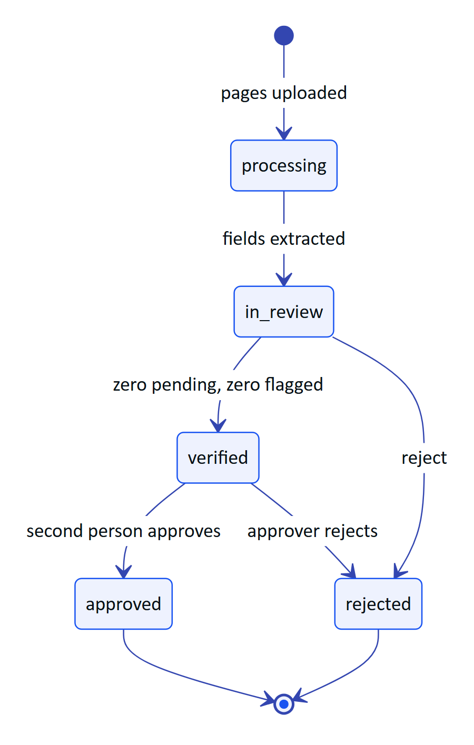
Figure 15. Audit document states on the console side (AuditDocStatus in auditdoc.ts)
The reviewer sees each extracted value beside its crop of the page, with the engines that read it and their agreement. Values where at least two independent engines match with confidence of 0.8 or more can be confirmed in bulk; everything else is confirmed, corrected or flagged one by one, and the original reading is always kept. Verify is blocked while any item is pending or flagged. Approval needs auditdoc.approve (admins and managers) and must come from someone other than the verifier, except in demo tenants where self-approval is allowed and recorded as such. The approved PDF carries the verification trail, the searchable original and a reconstructed page.
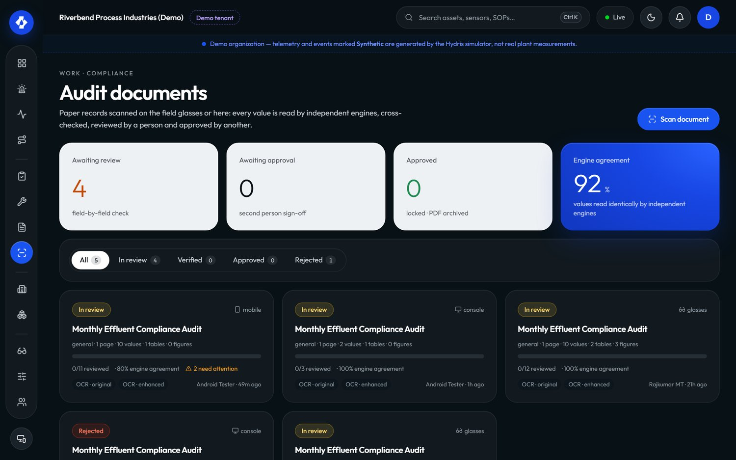
Figure 16. Audit documents review in the console
Table 10. Audit review requirements
ID | Requirement | Pri | Status
FR-064 | Confirm, correct, flag, reset; verify gate | M | Built
FR-069 | Bulk-confirm agreed multi-engine values | S | Built
FR-065 | Independent approval (four eyes) | M | Built
FR-066 | PDF with trail, searchable original, reconstruction | M | Built
FR-068 | Electronic signature with re-authentication | S | Planned

Status: Built. Next: electronic signature, which regulated customers will ask for before audit documents replace paper.

1.10 Reports, insights and the assistant

Purpose and scope
Managers and auditors need numbers they can defend. Reports (/console/reports, insights.ts) cover inspections, alarms, maintenance, devices and operators, in JSON for the page and CSV for export (FR-081). The alarm report includes median minutes to acknowledge; the inspection report includes on-time rate and the share submitted via glasses. Those fields are the data sources for most of the pilot KPIs below.
The assistant is grounded and read-only. In the console it appears as SOP retrieval on the documents page (FR-070); the voice assistant (/assistant/ask) answers only from tenant data through read tools and has no write tools (FR-072, FR-078). Its full design is in the assistant part of this book.
Table 11. Reports and insights requirements
ID | Requirement | Pri | Status
FR-081 | Reports for five areas in JSON and CSV | M | Built
FR-080 | Realtime events with replay | M | Built
FR-084 | Simulation scenarios in demo tenants only | M | Built
FR-120 | Compliance summary per discharge point | S | Planned
FR-121 | Scheduled report delivery by email | C | Planned
FR-122 | Grounded shift handover summary | C | Planned

Status: operational reports Built. Gap: no compliance summary against consent limits, which is the report regulators actually ask for. Next: FR-120 for the pilot.

1.11 Organization admin

Purpose and scope
Admins set up who can do what. The admin area covers operators (members), roles, invitations, sessions, organization settings, the audit log and, for Hydris staff, platform administration. Its rule is no escalation: nobody can grant a role above their own (assignableRoles).
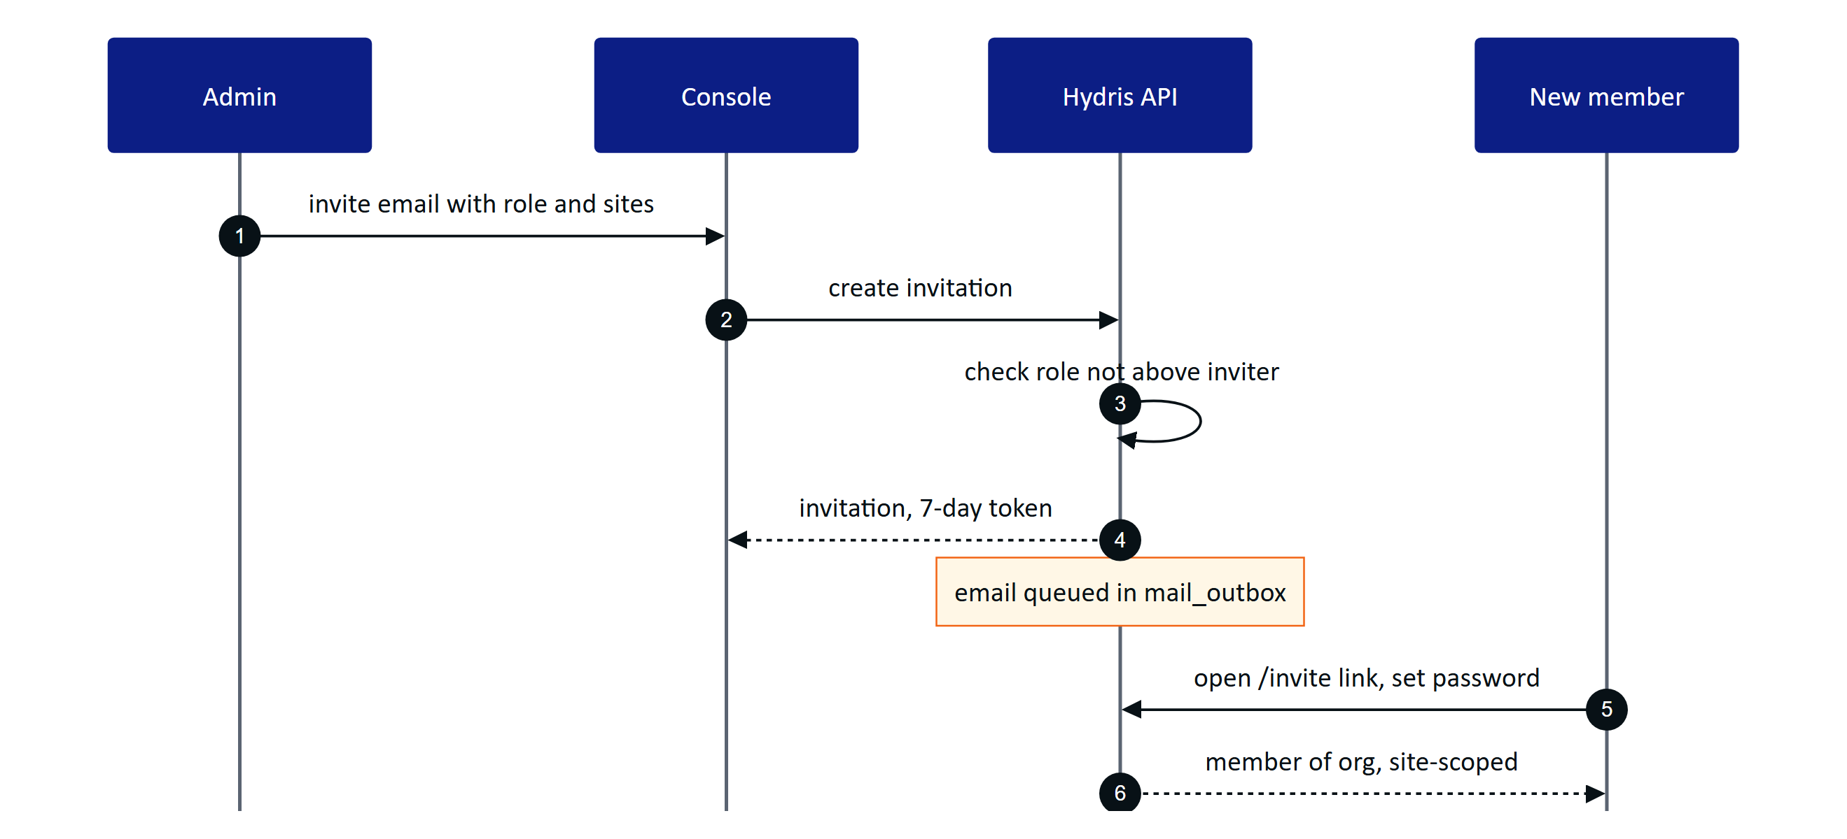
Figure 17. Inviting a member (org.ts, auth.ts)
Invitation emails are written to mail_outbox but not yet sent; until email delivery lands (FR-086), the admin shares the link. Members can belong to several organizations and switch between them (FR-006); sessions can be listed and revoked (FR-009); TOTP MFA is available (FR-002). Organization settings need org.manage, held only by org_admin.
The audit log page (/console/audit, FR-087) filters the append-only trail by action and entity and shows actor, time and IP; no API path updates or deletes an audit event (FR-082). Platform admins create and suspend customer organizations at /console/platform (FR-010); members of a suspended organization cannot sign in to it.
Table 12. Organization admin requirements
ID | Requirement | Pri | Status
FR-004 | Invitations, 7-day token, no escalation | M | Built
FR-006 | Multi-organization membership and switch | S | Built
FR-009 | Session listing and revocation | S | Built
FR-012 | Fixed role matrix | M | Built
FR-082 | Append-only audit trail | M | Built
FR-087 | Audit log page with filters | M | Built
FR-010 | Platform organization create and suspend | M | Built
FR-005 | Password reset email | M | Partial
FR-086 | Email delivery (SMTP, SES or Resend) | M | Planned
FR-011 | SSO with SAML 2.0 and OIDC | S | Planned

Status: Built apart from email delivery and SSO. Next: email delivery before the pilot, SSO for general availability.

1.12 Console success metrics and gaps

Success metrics
The console is measured by whether supervisors and managers act on field records quickly and trust them. All values below are pilot targets from the PRD, not measured results.
Table 13. Console metrics (pilot targets)
Area | Metric | Source | Target
Alarms | Median time to acknowledge, critical and high | Alarm report | Under 5 minutes
Alarms | Acknowledged but unresolved older than 24 h | Alarm list | Visible daily, trending down
Rounds | On-time completion | Inspection report onTimeRate | 95 % or more
Rounds | Share submitted via glasses | Inspection report viaGlasses | 50 % or more
Evidence | Approval cycle, capture to approval | Audit documents | Under 24 hours
Evidence | Reviewer edits per reviewed field | Audit documents | Under 5 %
Security | Device revocation to stream end | Event stream | 30 s or less
Security | Cross-tenant incidents | Security review | 0

< 5 min  Time to acknowledge  target, critical and high |  | 95 %  On-time rounds  target |  | < 24 h  Evidence approval  target |  | 0  Cross-tenant incidents  target

Gaps and next steps
Table 14. Console gaps in priority order
Gap | Requirement | Effect today | Next step
No email delivery | FR-086, FR-005 | Admin shares invite links by hand | Wire SMTP, SES or Resend with retries
No escalation | FR-037 | Unacknowledged alarms rely on someone watching | Configurable escalation to site supervisor
Stale checks daily on Vercel | FR-035 | Stale alarms late on serverless | Higher-frequency scheduler
No recurring schedules | FR-047 | Rounds dispatched by hand | Calendar and runtime schedules
No compliance summary | FR-120 | Regulator reports built outside Hydris | Daily min, max, average against consent
No SSO | FR-011 | Local passwords only | SAML and OIDC per organization
No electronic signature | FR-068 | Approval not Part 11-style | Re-authentication on approve
Auditor cannot open audit log | roles.ts | viewer lacks audit.read | Decide on an auditor role
Performance not measured | NFR-001, NFR-002 | Targets unproven | Load and latency tests before pilot

IMPORTANT
The console is functionally complete for a supervised pilot. The items that block an unsupervised pilot are email delivery, alarm escalation and a reliable stale-data schedule.

